Chapter 4 Name:_________________
Atomic Structure Mr. Rosener

Chapter 4
Atomic Structure

Chapter 4 Pretest
1. True or False: Compounds have fixed
compositions.

2. What is an atom?

3. Which of the following units is a unit
of mass?
a. mL b. °C
c. g d. cm

4. What is density?

5. Which two of the following events can
take place when a liquid absorbs energy?
a. The average kinetic energy of the
particles in the liquid increases.
b. The temperature decreases.
c. The liquid freezes.
d. The liquid changes to a gas.

Section 1: Studying Atoms

Ancient Greek Models of Atoms
- The philosopher __________________ believed that all matter consisted of extremely small particles that could not be divided.
- He called these particles atoms from the Greek word atomos, which means “__________” or “________________.”
- ___________________ did not think there was a limit to the number of times matter could be divided.
- Aristotle thought that all substances were built up from only _____________ elements—earth, air, fire, and water

- Which Philosopher was correct: Democritus or Aristotle?

- For many centuries, most people accepted __________________ views on the structure of matter.
- BUT
- ____________________ would be proven correct by:

John Dalton: Dalton’s Atomic Theory
- Dalton studied the behavior of ____________ in air.
- Dalton developed a theory to explain why the elements in a compound always join in the same way.
- Dalton proposed the theory that all ____________ is made up of individual particles called ____________, which cannot be _________________.

Dalton’s Atomic Theory
- All elements are composed of ____________.
- All atoms of the same element have the ___________ mass, and atoms of different elements have ____________ masses.
- Compounds contain atoms of more than one ____________.
- In a particular compound, atoms of different elements always ________________ in the same way.

JJ Thomson: Thomson’s Model of the Atom
- When some materials are rubbed, they gain the ability to ___________ or ______________ other materials.
- Joseph John Thomson (1856–1940), better known as J. J. Thomson, used an electric current to learn more about atoms.
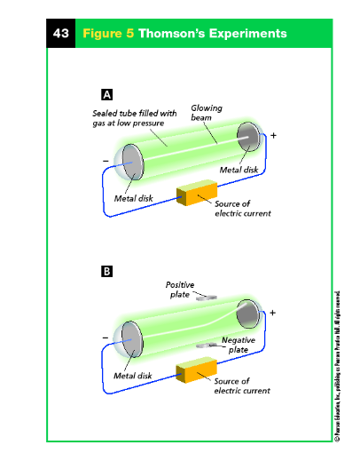

- Thomson’s experiments provided the first evidence that ____________ are made of even _____________ particles.
- He discovered the _____________.
- Electron – ____________ charged particle found in the atom
Thomson’s Model
- In Thomson’s model of the atom, the _____________ charges were evenly scattered throughout an atom filled with a positively charged mass of matter.
- The model is called the “____________ ____________” model, after a traditional English dessert.

Ernest Rutherford: Rutherford’s Atomic Theory
- In 1899, Ernest Rutherford discovered that uranium emits fast-moving particles that have a positive charge.
- He named them ____________ particles
- what happens to alpha particles when they pass through a thin sheet of _____________.
Rutherford’s Hypothesis
- hypothesized that the mass and charge at any location in the gold would be too ______________ to change the path of an alpha particle.
- He predicted that most particles would travel in a _________ path from their source to a screen that lit up when struck.
The Gold Foil Experiment
- More particles were ________________ than he expected.
- Some of the alpha particles behaved as though they had struck an object and bounced straight __________.
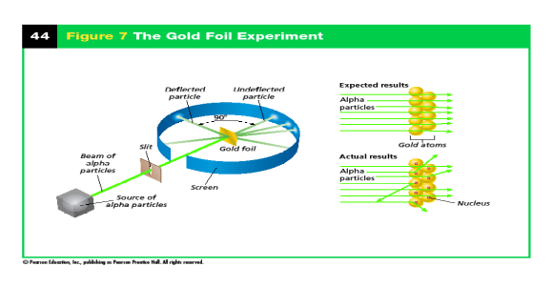

Discovery of the ______________
- Rutherford concluded that the positive charge of an atom is not evenly spread throughout the atom.
- It is concentrated in a very small, _____________ area that Rutherford called the _____________
- The _______________ is a dense, positively charged mass located in the center of the atom.
Rutherford’s Atomic Theory
- According to Rutherford’s model, all of an atom’s _____________ charge is concentrated in its ___________.
- Rutherford also discovered the _______________
- Proton – __________ charged particle located in the nucleus

Reviewing Concepts
- 1. What theory did Dalton propose about the structure of matter?
- 2. What evidence did J. J. Thomson provide about the structure of an atom?
- 3. What did Rutherford discover about the structure of an atom?
- 4. What evidence did Thomson have that his glowing beam contained negative particles?
- 5. Why was Dalton’s model of the atom changed after Thomson’s experiment?

Section 2: The Structure of an Atom

Properties of Subatomic Particles
- By 1920, Rutherford had seen evidence for the existence of two subatomic particles and had predicted the existence of a third particle.
- Protons, electrons, and neutrons are _________ particles.

Proton
- A _______________ is a ______________ charged subatomic particle that is found in the nucleus of an atom.
- Each proton is assigned a charge of +1.
Electron
- An _____________ is a ______________ charged subatomic particle that is found in the space outside the nucleus.
- Each electron has a charge of -1.
Neutron
- In 1932, the English physicist James Chadwick designed an experiment to show that neutrons exist
- A ______________ is a _______________ subatomic particle that is found in the nucleus of an atom.
- It has a mass almost exactly equal to that of a __________.

Comparing Subatomic Particles
Protons, electrons, and neutrons can be distinguished by mass, charge, and location in an atom.
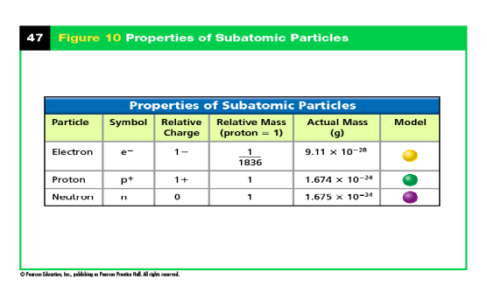

Atomic Number and Mass Number

Atomic Number
- The ______________________ of an element equals the number of __________ in an atom of that element.
- Atoms of different elements have different numbers of ________________.
- Each positive charge in an atom is ______________ by a negative charge because atoms are neutral.
- So the atomic number of an element also ____________ the number of electrons in an atom.

What is the atomic number of the following elements.
- Potassium (K)
- Oxygen (O)
- Iron (Fe)
- Helium (He)

Mass Number
- The ________________of an atom is the ___________ of the protons and neutrons in the nucleus of that atom.
- An atom of aluminum with 13 protons and 14 neutrons has a mass number of 27.
- If you know the atomic number and the mass number of an atom, you can find the number of neutrons by ___________.

Number of neutrons = __________________________________

What is the Atomic Mass of the following elements
- Potassium (K) - Neutrons = 20
- Oxygen (O) – Neutrons = 8
- Iron (Fe) – Neutrons = 30
- Helium (He) – Neutrons = 2

Isotopes
- _____________ are atoms of the same element that have different numbers of _________ and different mass numbers.
- Isotopes of an element have the ________ atomic number but ______________ mass numbers because they have _________________ numbers of neutrons.
  - Hydrogen atom and it’s 3 isotopes
  - Hydrogen isotopes are the only isotopes to have special names.
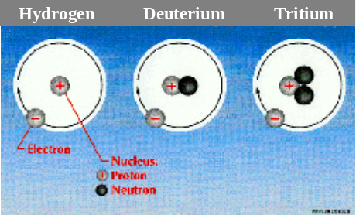

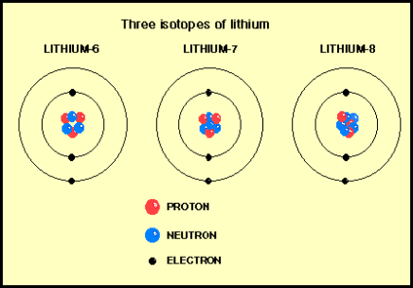

Questions
- What is the difference between Oxygen-16 and Oxygen-18?

- How are they the same?

- What part of the atom do isotopes have to do with?

Reviewing Concepts
- 1. Name three subatomic particles.
- 2. Name three properties you could use to distinguish a proton from an electron.
- 3. Which characteristic of an atom always varies among atoms of different elements?
- 4. How are the isotopes of an element different from one another?
- 5. What do neutrons and protons have in common? How are they different?
- 6. How can atoms be neutral if they contain charged particles?
- 7. What is the difference between atoms of oxygen-16 and oxygen-17?

Section 3: Modern Atomic Theory

Bohr’s Model of the Atom
- Niels Bohr(1885–1962), a Danish physicist who worked for a while with Rutherford.
- Bohr’s model focused on the ________________.
- A description of the arrangement of electrons in an atom is the centerpiece of the modern atomic model.
- Energy Levels
- The possible energies that electrons in an atom can have are called _______________________.
- An electron in an atom can move from one energy level to another when the atom _________ or __________ energy.
- Scientists can measure the energy gained when electrons absorb energy and move to a __________ energy level.
- They can measure the energy released when the electron returns to a ____________ energy level.

Electron Cloud Model
- An ___________________ is a visual model of the most likely locations for electrons in an atom.
- Scientists use the electron cloud model to describe the possible locations of ______________ around the nucleus.


Atomic Orbitals
- An ______________ is a region of space around the nucleus where an electron is likely to be found
- An electron cloud is a good approximation of how _______________ behave in their orbitals.

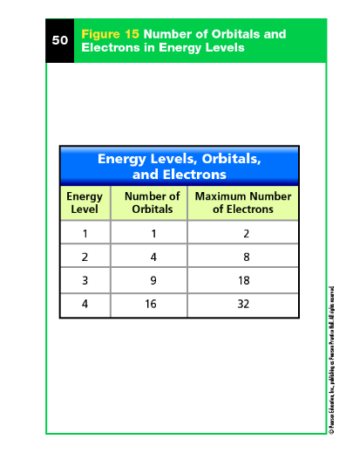

Electron Configurations
- A configuration is an ____________________ of objects in a given space.
- An electron configuration is the arrangement of _________________ in the _______________ of an atom.
- The most ___________ electron configuration is the one in which the electrons are in orbitals with the ___________ possible energies.
- When all the electrons in an atom have the lowest possible energies, the atom is said to be in its __________________.
Construct Bohr Models
He | C
Mg | Cl

Models of the Atom
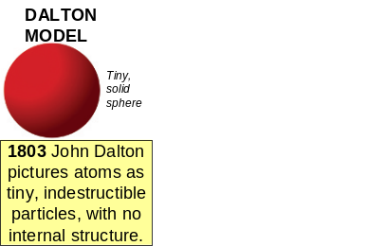
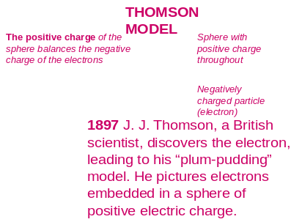
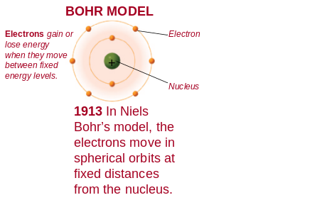
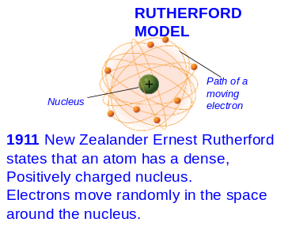


ELECTRON CLOUD MODEL (Modern Thoery)
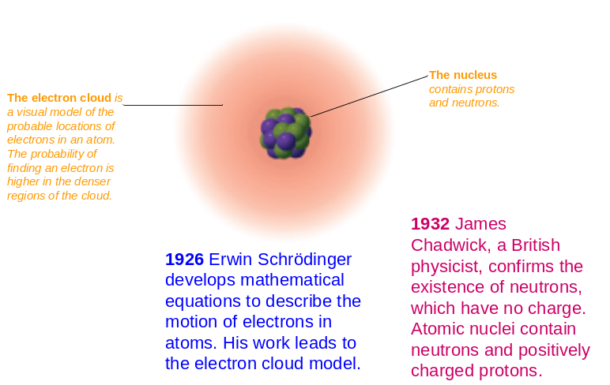

Reviewing Concepts
- 1. When is an electron in an atom likely to move from one energy level to another?
- 2. What model do scientists use to describe how electrons move around the nucleus?
- 3. Describe the most stable configuration of the electrons in an atom.
- 4. What did Bohr contribute to modern atomic theory?
- 5. What does an electron cloud represent?

